Esraa Hassouna
IOT
Linux lab 2

- Create a user account with the following attribute
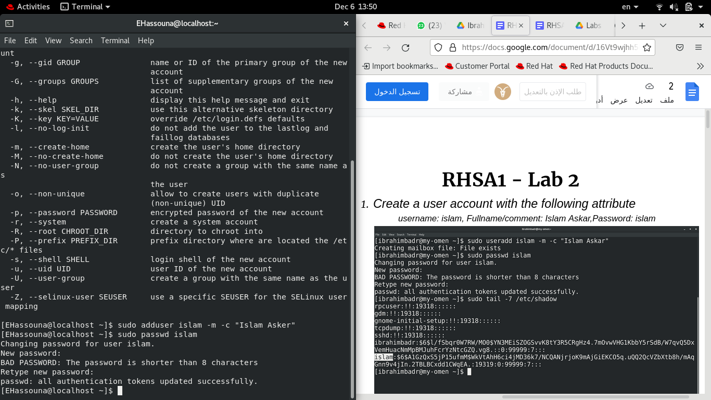
username: islam, Fullname/comment: Islam Askar,Password: islam

2. Create a user account with the following attribute
Username: baduser, Full name/comment: Bad User, Password: aduser

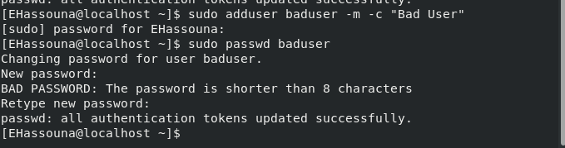

3.Create a supplementary (Secondary) group called pgroup with group ID of 30000
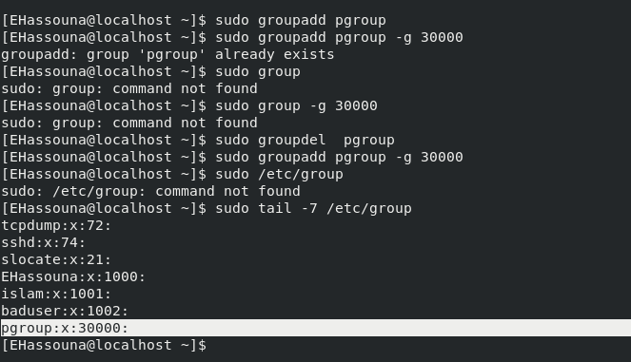

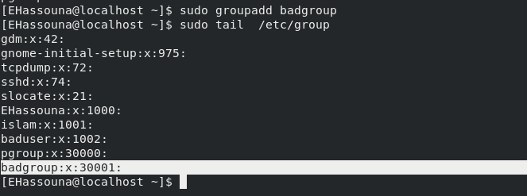
4.Create a supplementary group called badgroup

5.Add islam user to the pgroup group as a supplementary group
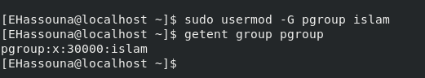

6. Modify the password of islam's account to password
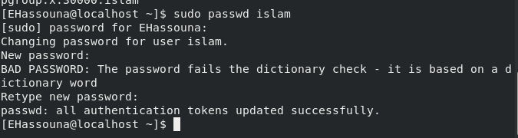

7. Modify islam's account so the password expires after 30 days

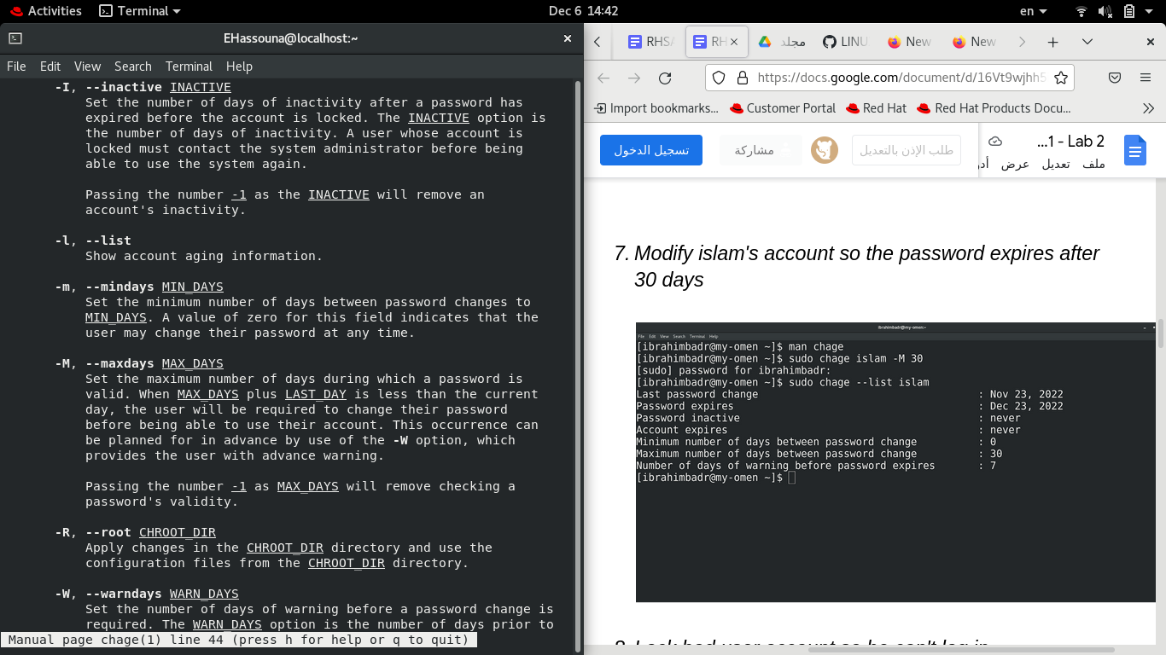

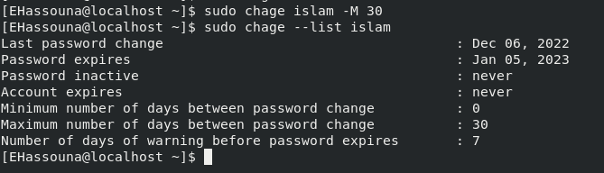

8.Lock bad user account so he can't log in

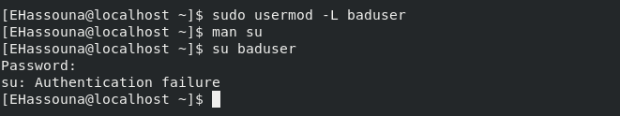

9.Delete bad user account
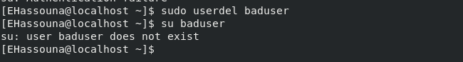

10.Delete the supplementary group called badgroup.
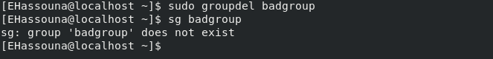

11.Create a folder called myteam in your home directory and change its permissions to read only for the owner.
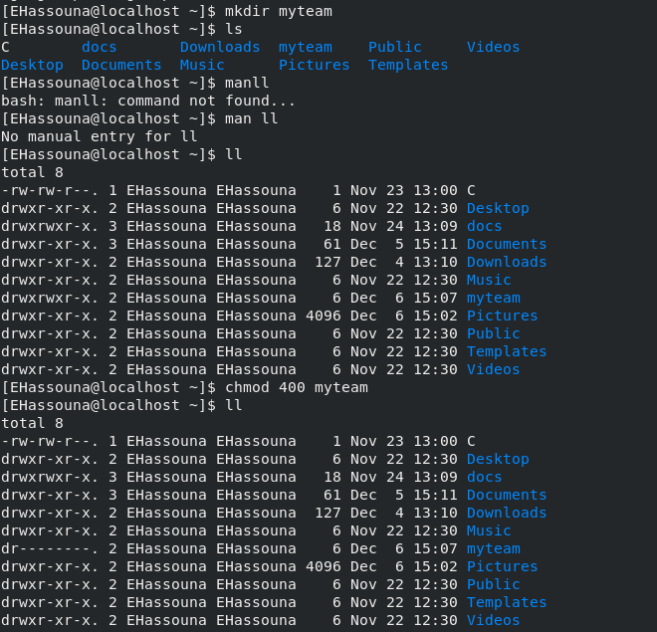

12. Log out and log in by another user
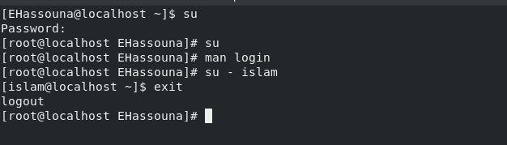

13.Try to access (by cd command) the folder (myteam)
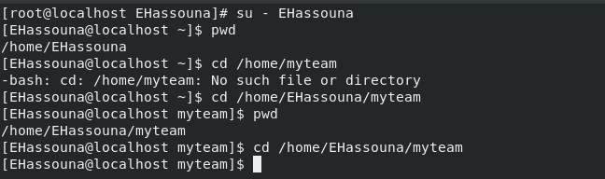

14.Change the permissions of myteam file to give owner read and write permissions and for group write and execute and execute only for the others (using chmod in 2 different ways)
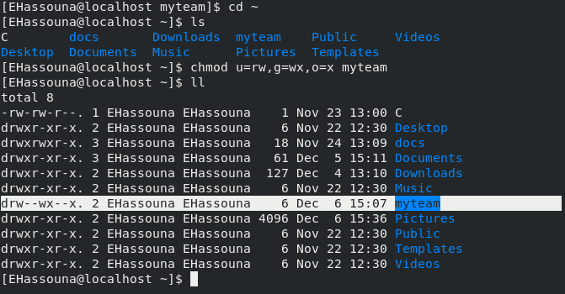

15.Change your default permissions to be as above.

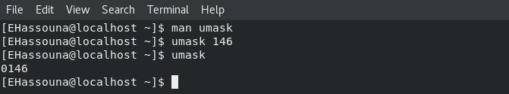

16. What is the maximum permission a file can have, by default when it is just created? And what is that for directory?

Maximum number of of permissions files: read and write
Maximum number of permissions in directory: read, write and execute.

17. Change your default permissions to be no permission to everyone then create a directory and a file to verify.
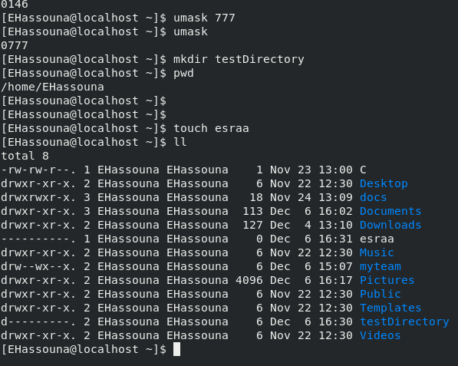

18. What are the minimum permission needed for:
Copy a directory (permission for source directory and permissions for target parent directory)
Source: r,x Destination: w,x
Copy a file (permission for source file and and permission for target parent directory)
Source: r,x Destination: w,x
Delete a file
Source (parent): w,x
Change to a directory
w,x
List a directory content (ls command)
r
View a file content (more/cat command)
r
Modify a file content
w

19. Create a file with permission 444. Try to edit in it and to remove it? Note what happened.

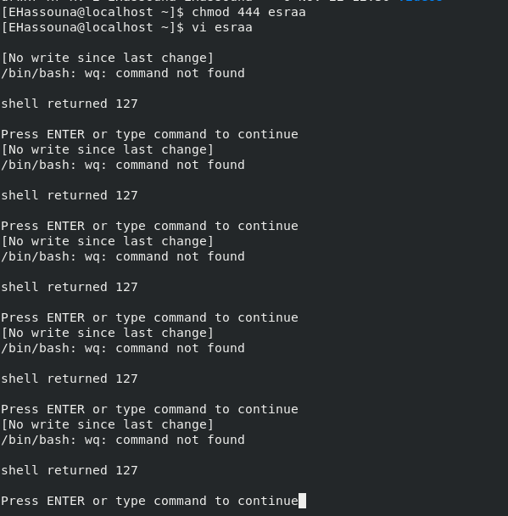

20. What is the difference between the “x” permission for a file and for a directory?
X permission is granted for directories by default and not granted to files by default.

